Best Available Techniques
for Pollution Prevention and Control
in the European Fertilizer Industry

Booklet No. 2 of 8:

Production of NITRIC ACID

EFMA
European Fertilizer Manufacturers’ Association

Ave. E van Nieuwenhuyse 4
B-1160 Brussels
Belgium

Copyright 1995 – EFMA

This publication has been prepared by member companies of the European Fertilizer Manufacturers’ Association (EFMA). Neither the Association nor any individual member company can accept liability for accident or loss attributable to the use of the information given in this Booklet.

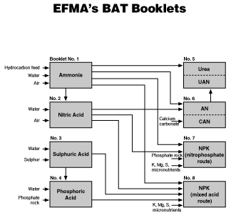

CONTENTS

PREFACE | 4

DEFINITIONS | 6

1. INTRODUCTION  2. DESCRIPTION OF PRODUCTION PROCESSES  2.1 Processes used by the European Fertilizer Industry  2.2 Process Basis  2.3 Medium Pressure, Single Pressure Plants  2.4 Dual Pressure Plants  2.5 High Pressure, Single Pressure Plants  3. DESCRIPTION OF STORAGE AND TRANSFER EQUIPMENT  3.1 Storage of Nitric Acid  3.2 Transfer Equipment for Nitric Acid  4. ENVIRONMENTAL DATA  4.1 Emissions and Wastes  4.2 Waste Minimisation and Treatment  5. EMISSION MONITORING  6. MAJOR HAZARDS  6.1 Equipment/Piping Failure  6.2 Explosion Hazard due to the Air Ammonia Mixture  6.3 Explosion of Nitrite/Nitrate Salts  7. OCCUPATIONAL HEALTH & SAFETY  8. SUMMARY OF BAT EMISSION LEVELS  8.1 Achievable Emission Levels for New Plants  8.2 Achievable Emission Levels for Existing Plants  8.3 Cost of Pollution Control Measures  9. REFERENCES | 7  8  8  8  10  12  14  14  14  14  15  15  16  20  20  21  21  21  21  22  22  22  22  22

GLOSSARY OF TERMS  APPENDIX 1 Emission Monitoring in Nitric Acid Plants  APPENDIX 2 General Product Information on Nitric Acid | 23  26  29

PREFACE

The European Fertilizer Manufacturers Association (EFMA) has prepared eight Booklets on Best Available Techniques (BAT) in response to the proposed EU Directive on integrated pollution prevention and control (IPPC Directive). The Booklets have been prepared by EFMA experts drawn from member companies. They cover the production processes of the following products:

No. 1  No. 2  No. 3  No. 4  No. 5  No. 6  No. 7  No. 8 | Ammonia  Nitric Acid  Sulphuric Acid  Phosphoric Acid  Urea and Urea Ammonium Nitrate (UAN)  Ammonium Nitrate (AN) and Calcium Ammonium Nitrate (CAN)  NPK Compound Fertilizers by the Nitrophosphate Route  NPK Compound Fertilizers by the Mixed Acid Route

The Booklets reflect industry perceptions of what techniques are generally considered to be feasible and present achievable emission levels associated with the manufacturing of the products listed above. The Booklets do not aim to create an exhaustive list of BAT but they highlight those most widely used and accepted. They have been prepared in order to share knowledge about BAT between the fertilizer manufacturers, as well as with the regulatory authorities.

The Booklets use the same definition of BAT as that given in the proposed IPPC Directive (see below). BAT covers both the technology used and the management practices necessary to operate a plant efficiently and safely. The EFMA Booklets focus primarily on the technological processes, since good management is considered to be independent of the process route. The industry recognises, however, that good operational practices are vital for effective environmental management and that the principles of Responsible Care should be adhered to by all companies in the fertilizer business.

The Booklets give two sets of BAT emission levels:-
- for existing production units where pollution prevention is usually obtained by revamps or end-of-pipe solutions
- for new plants where pollution prevention is integrated in the process design.

The emission levels refer to emissions during normal operations of typical sized plants. Other levels may be more appropriate for smaller or larger units and higher emissions may occur in start-up and shut-down operations and in emergencies.

Only the more significant types of emissions are covered and the emission levels given in the Booklets do not include fugitive emissions and emissions due to rainwater. Furthermore, the Booklets do not cover noise, heat emissions and visual impacts.

The emission levels are given both in concentration values (ppm, mg/m³ or mg/l) and in load values (emission per tonne of product). It should be noted that there is not necessarily a direct link between the concentration values and the load values.

EFMA recommends that the given emission levels should be used as reference levels for the establishment of regulatory authorisations. Deviations should be allowed as governed by:
– local environmental requirements, given that the global and inter-regional environments are not adversely affected
– practicalities and costs of achieving BAT
– production constraints given by product range, energy source and availability of raw materials.

If authorisation is given to exceed these BAT emission levels, the reasons for the deviation should be documented locally.

Existing plants should be given ample time to comply with BAT emission levels and care should be taken to reflect the technological differences between new and existing plants when issuing regulatory authorisations, as discussed in these BAT Booklets.

A wide variety of methods exist for monitoring emissions. The Booklets provide examples of methods currently available. The emission levels given in the Booklets are subject to some variance, depending on the method chosen and the precision of the analysis. It is important when issuing regulatory authorisations, to identify the monitoring method(s) to be applied. Differences in national practices may give rise to differing results as the methods are not internationally standardised. The given emission levels should not, therefore, be considered as absolute but as references which are independent of the methods used.

EFMA would also advocate a further development for the authorisation of fertilizer plants. The plants can be complex, with the integration of several production processes and they can be located close to other industries. Thus there should be a shift away from authorisation governed by concentration values of single point emission sources. It would be better to define maximum allowable load values from an entire operation, eg from a total site area. However, this implies that emissions from single units should be allowed to exceed the values in the BAT Booklets, provided that the total load from the whole complex is comparable with that which can be deduced from the BAT Booklets. This approach will enable plant management to find the most cost-effective environmental solutions and would be to the benefit of our common environment.

Finally, it should be emphasised that each individual member company of EFMA is responsible for deciding how to apply the guiding principles of the Booklets.

Brussels, 1 March 1995

DEFINITIONS

The following definitions are taken from the proposed EU Directive of September 1993 on Integrated Pollution Prevention and Control:-

“Best Available Techniques” (BAT) signify the latest stage in the development of activities, processes and their methods of operation which indicate the practical suitability of particular techniques as the basis of emission limit values for preventing or, where that is not practicable, minimising emissions to the environment as a whole, without pre-determining any specific technology or other techniques.

“Techniques” include both the technology used and the way in which the installation is designed, built, maintained, operated and decommissioned. The techniques must be industrially feasible, in the relevant sector, from a technical and economic point of view.

“Available” techniques mean those developed on a scale which allows implementation in the relevant industrial context under economically viable conditions and being reasonably accessible to the operator.

“Best” means most effective in achieving a high level of protection for the environment as a whole, taking into account the potential benefits and costs which may result from action or lack of action.

1. INTRODUCTION

This Booklet is concerned with the environmental issues resulting from the production of nitric acid. It deals with gaseous, liquid and solid waste discharges to air, water and land and the actions to be taken to minimise such discharges.

All plants for the production of nitric acid are currently based on the same basic chemical operations:-
Oxidation of ammonia with air to give nitric oxide
Oxidation of the nitric oxide to nitrogen dioxide and absorption in water to give a solution of nitric acid

The efficiency of the first step is favoured by low pressure whereas that of the second is favoured by high pressure. These considerations, combined with economic reasons give rise to two types of nitric acid plant, single pressure plants and dual pressure plants.

In the single pressure plant, the oxidation and absorption steps take place at essentially the same pressure. In dual pressure plants absorption takes place at a higher pressure than the oxidation stage.

The oxidation and absorption steps can be classified as :-
Low pressure (pressure below 1.7bar)
Medium pressure (pressure between 1.7 and 6.5bar)
High pressure (pressure between 6.5 and 13bar)

Except for some very old plants, single pressure plants operate at medium or high pressure and dual pressure plants operate at medium pressure for the oxidation stage and high pressure for the absorption.

The main unit operations involved in the nitric acid process are the same for all types of plant and in sequential order these are:-
Air filtration
Air compression
Air/ammonia mixing
Air/ammonia oxidation over catalytic gauzes
Energy recovery by steam generation and/or gas re-heating
Gas cooling
Gas compression, energy recovery and cooling (dual pressure plants only)
Absorption, with the production of nitric acid
Waste gas (tail gas) heating
Energy recovery by expansion of the waste gas to atmosphere, in a gas turbine

The typical plants described in this Booklet will be limited to the single pressure plant and to the dual pressure, medium pressure/high pressure plant, as the absorption is always based on medium or high pressures. These are the processes most used in the European industry.

The fertilizer industry uses weak nitric acid in the range of 50 to 65% strength and thus the high concentration (above 70% weight) nitric acid production process is not included.

A typical plant of 1000t/d capacity has been selected for further description but all data are calculated for one tonne of 100% nitric acid because plant size has only a marginal effect on input and output-specific data, apart from energy. The most common energy scheme has been adopted. That is: make up power for the compressor set power supplied by a condensing steam turbine, energy recovery from tail gas in a gas turbine and pumps driven by electric motors.

Raw materials (ammonia and demineralised water) and cooling water facilities are required in addition to the nitric acid process unit itself, as well as an auxiliary boiler which is used by some units for start-up. The production of ammonia is covered by EFMA BAT Booklet No 1.

2. DESCRIPTION OF PRODUCTION PROCESSES

2.1 Processes used by the European Fertilizer Industry

At the end of 1992 a tentative survey of the type of plants still in operation within the European Community gave the following results. Plants are classified by oxidation pressure and absorption pressures.

Dual pressure processes :  Low pressure/Medium pressure  Medium pressure/High pressure  Single pressure processes:  Medium pressure/Medium pressure  High pressure/High pressure  Total number of plants | 9 (oldest plant)  36 (newest plant)  22  11  78

The typical capacity of the newest plants is 1000t/d

These plant numbers are probably optimistic as the European industry is engaged in considerable rationalisation.

The various processes used in Europe are discussed below and further details can be found in Reference [1].

2.2 Process Basis

Ammonia is reacted with air on platinum/rhodium alloy catalysts in the oxidation section of nitric acid plants. Nitric oxide and water are formed in this process according to the main equation:
4NH₃ + 5O₂ –––––> 4NO + 6H₂O (1)
Simultaneously nitrous oxide, nitrogen and water are formed as well, in accordance with the following equations:–
4NH₃ + 3O₂ –––––> 2N₂ + 6H₂O (2)
4NH₃ + 4O₂ –––––> 2N₂O + 6H₂O (3)

The yield of nitric oxide depends on pressure and temperature as indicated in the table.
Pressure (bar) | Temperature (°C) | NO yield (%)
below 1.7  1.7 to 6.5  above 6.5 | 810 - 850  850 - 900  900 - 940 | 97  96  95

The catalyst typically consists of several woven or knitted gauzes formed from wire containing about 90% platinum alloyed with rhodium for greater strength and sometimes containing palladium. Air pollution and contamination from the ammonia can poison the catalyst. This effect, as well as poor ammonia-air mixing and poor gas distribution across the catalyst, may reduce the yield by 10%. Some of the platinum and rhodium vaporises during the reaction process and in most cases a platinum recovery system is installed below the catalyst. In this system a palladium alloy sometimes used with gold and known as a “getter” or catchment, allows a 60 to 80% recovery of the total catalyst losses.

The enthalpy of the hot reaction gases is used to produce steam and/or to preheat the waste gas (tail gas). The heated waste gas is discharged to the atmosphere through a gas turbine for energy recovery.

The combustion gas after this heat transfer for energy recovery, has a temperature of 100 to 200°C, depending on the process and it is then further cooled with water. The water produced in reactions (1) to (3) is then condensed in a cooler-condenser and transferred to the absorption column.

Nitric oxide is oxidised to nitrogen dioxide as the combustion gases are cooled, according to the equation:
2NO + O₂ <–––––> 2NO₂ (4)

For this purpose,secondary air is added to the gas mixture obtained from the ammonia oxidation to increase the oxygen content to such a level that the waste gas leaving the plant has a normal oxygen content of between 2 and 4% by volume. The absorber is operated with a counter–current flow of water. The absorption of the nitrogen dioxide and its reaction to nitric acid and nitric oxide take place simultaneously in the gaseous and liquid phases according to equations (4) and (5). These reactions depend on pressure and temperature to a large extent and are favoured by higher pressure and lower temperature.

3NO₂ + H₂ O <–––––> 2HNO₃+ NO (5)

Reaction (5) is exothermic and continuous cooling is therefore required within the absorber. As the conversion of NO to NO₂ is favoured by low temperature, this reaction will take place significantly until the gases leave the absorption column. The nitric acid produced in the absorber contains dissolved nitrogen oxides and is then bleached by the secondary air.

2.3 Medium Pressure, Single Pressure Plants

A typical plant is represented in the block diagram in Figure 1 and includes:

Ammonia evaporation section
Liquid ammonia from storage is evaporated using water or condensates and superheated to prevent any liquid carry-over.

Ammonia filtration section
Gaseous ammonia is filtered to remove any rust from carbon steel equipment. Some plants also use a magnetic filter on the liquid ammonia.

Air filtration section
High purity air is obtained by using two or three stage filtration. In some plants there is additional filtration of the air/ammonia mixture.

Air compression section
An air compressor is driven by a tail gas expander and by a steam condensing turbine.

Mixing section
Modern plants use static mixers to give the high quality mixture which is essential to maintain good catalyst operation.

Catalytic reactor section
The catalytic reactor is designed to give a uniform distribution of the air/ammonia mixture over the catalyst gauzes. Maintenance of the catalyst operating temperature is very important for the NO yield. This is achieved by adjusting the air/ammonia ratio and ensuring that the lower explosive limit for ammonia in air is not exceeded.

Heat recovery sections
The catalytic reactor is typically mounted as the upper part of a vessel which contains the first heat recovery section (steam superheater and steam generator). A set of gas/gas heat exchangers transfers the energy from the gas leaving the boiler set, to the tail gas.

Cooling section
A cooler condenser ensures final cooling down to 50°C after the final heat recovery. Weak acid solution is formed and is separated and pumped to the absorption tower.

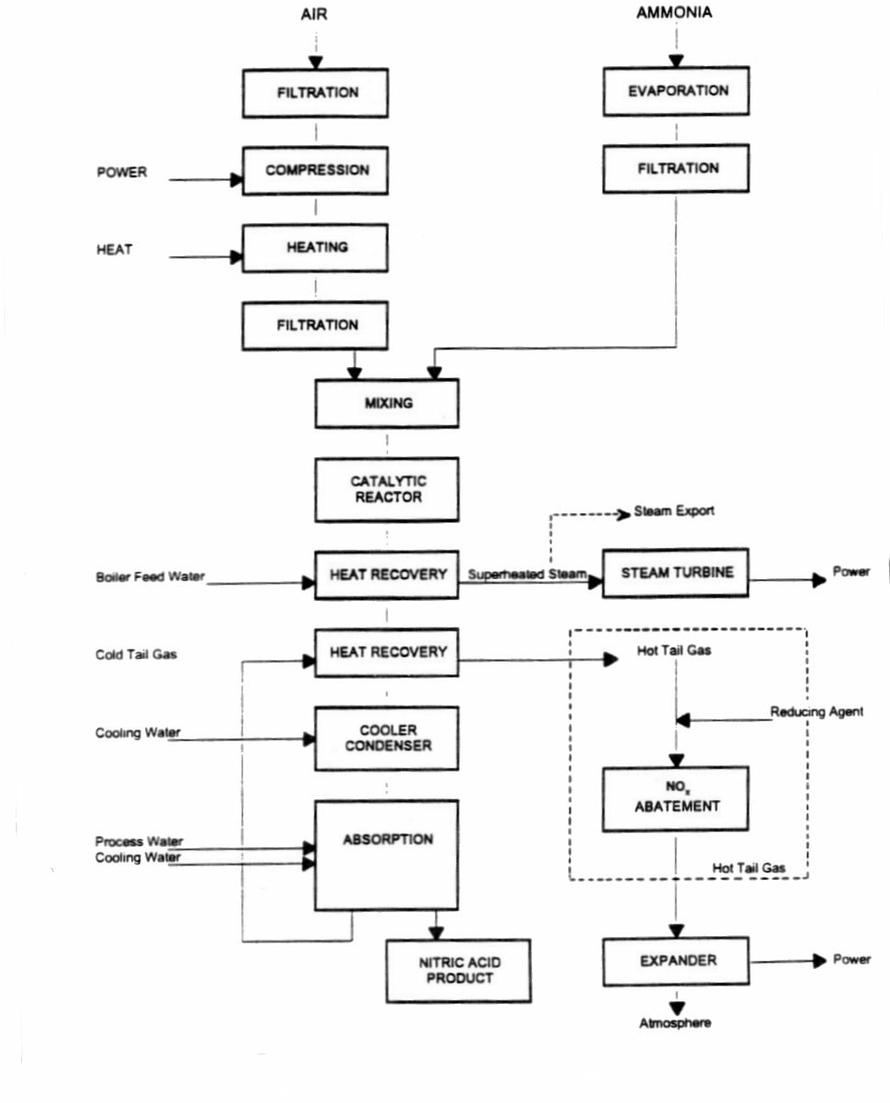
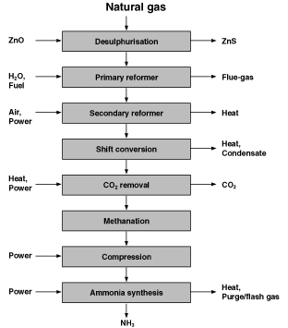
Figure 1 - Nitric Acid Production - Single Pressure Plant.

Absorption section
The modern absorber design uses counter-current flow circulation with high efficiency trays which are usually sieve trays or bubble cap trays. The tray spacing increases progressively from the bottom to the top of the absorber. Many of the trays are fitted with internal cooling coils to remove the heat of reaction. The absorption section consists of one or more columns in series.

Demineralised water or steam condensate is added at the top of the tower as make-up. The acid solution leaving the absorption section is rich in dissolved nitrogen oxides and is passed to a bleaching tower where it is contacted with a counter-current flow of secondary air. The secondary air and the nitrogen oxides which have been stripped out are mixed with the gases leaving the cooling section and are recycled to the absorption section. The gas leaving the absorption section is commonly known as tail gas.

Expander section
The tail gas from the absorber is passed through the heat recovery and the expander sections for energy recovery and is then passed to the stack.

Steam turbine section
The expander generates insufficient energy to drive the air compressor. A steam turbine using part of the superheated steam generated in the plant makes up the deficiency. The steam turbine is also used for plant start-up. In some plants the energy make-up comes from an electric motor and the generated steam is exported.

2.4 Dual Pressure Plants

A typical plant is represented in the block diagram in Figure 2. It is similar to the single pressure plant as far as the cooling section. After the cooling section the plant layout is as follows:-

NO_{x} compression section
In dual pressure plants the gases leaving the cooling section are mixed with the air and nitrogen oxides from the bleaching of the acid solution and compressed to a higher pressure for the absorption stage. The heat of compression is removed from the compressed gases by heat recovery into the tail gas or the boiler feed water.

Cooling section
A second cooler condenser reduces the temperature of the gases to about 50°C and the acid solution formed is mixed with the product acid.

Absorption section
The acid solution from the absorption section is passed to a column working at the pressure of the air compressor discharge, where it is stripped of the nitrogen oxides by a flow of air from the air compressor. The air and the stripped nitrogen oxides return to the NO_{x} gas compressor.

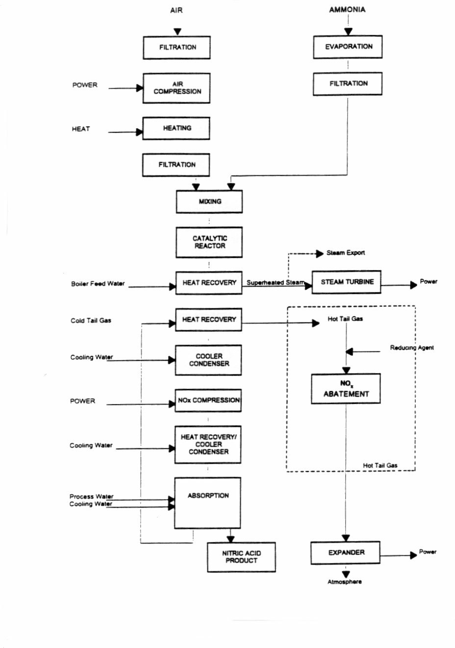
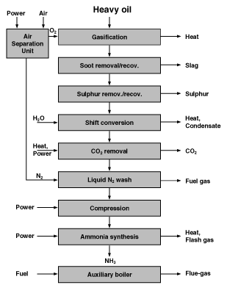
Figure 2 - Nitric Acid Production - Dual Pressure Plant

2.5 High Pressure, Single Pressure Plants

A typical high pressure, single pressure plant is similar in layout to the medium pressure single pressure plant (See Figure 1). The process parameters differ because of the higher operating pressure. The main differences are:-
A higher operating catalyst temperature and pressure with a lower NO yield and a greater loss of catalyst
A higher inlet pressure to the gas expander allowing a higher inlettemperature and thus more energy recovered in the expander and a smaller steam turbine
A higher operating pressure in the absorber with a lower tail gas NO_{x} content

3. DESCRIPTION OF STORAGE AND TRANSFER EQUIPMENT

3.1 Storage of Nitric Acid

Nitric acid is normally stored in flat bottomed, roofed tanks, made from low carbon austenitic stainless steel, installed in areas provided with suitable containment facilities. The acid level in the tank is monitored by means of a level indicator. A vent to the atmosphere allows the escape of gas which comes from liquid movement and thermal effects. It is normal to earth the tanks.

3.2 Transfer Equipment for Nitric Acid

Nitric acid is transported using rail tank cars, road tankers and less frequently, ships. Transfer is made by pumping or by gravity and pressurising for unloading large quantities should be avoided.

The recommended material for tanks, vessels and accessories is low carbon austenitic stainless steel.

4. ENVIRONMENTAL DATA

4.1 Emissions and Wastes

4.1.1 Gaseous emissions

4.1.1.1 Waste gas (Tail gas)
This is a continuous emission and depending on the process, the gas at the outlet of the absorber may vary within the following limits during stable operation:-

No_{x}  N₂O  O₂  H₂O  N₂  Flow | 100 to 2000ppmv  300 to 3500ppmv  1 to 4% by volume  0.3 to 0.7% by volume  balance  3130 to 3330Nm³/t 100% HNO₃  (3925 to 4180kg/t 100% HNO₃

Start-up and shut-down periods will normally increase the NO_{x} content of the tail gas at the stack during the few hours needed for the process to stabilise or for NO_{x} to be cleared from the plant.

4.1.1.2 Fugitive emissions
Water present in the liquid ammonia (typically 0.5%) concentrates in the ammonia vaporiser and periodic blow-down generates a small gaseous ammonia release.

4.1.2 Liquid wastes

4.1.2.1 Boiler blow-down
The dissolved salt content of the boiler water is controlled by a blow-down of the water in the steam drum.

4.1.2.2 Ammonia vaporiser blow-down
The build-up of water in the liquid ammonia in the vaporiser is controlled by a periodic blow-down.

4.1.2.3 Purging and sampling
Occasional emissions from the purging and sampling of nitric acid solutions.

4.1.2.4 Lubricating oil
Periodic replacement of the lubricating oil in rotating machines such as compressors, turbines and pumps.

4.1.3 Solid wastes

4.1.3.1 Ammonia oxidation catalyst
Periodic replacement of the catalyst is required due to losses and slow poisoning.

4.1.3.2 Catalyst recovery gauzes (catchment/getter)
Precious metal losses from the catalyst are trapped by the getter and as the efficiency of catchment decreases, the getter needs to be replaced.

4.1.3.3 NOx reduction catalyst
Periodic replacement of the catalyst due to loss of efficiency.

4.1.3.4 Filter cartridges
Periodic replacement of the cartridges due to build-up of pressure drop in the various elements used for ammonia, air and air/ammonia mixture filtration.

4.1.3.5 Solid deposit
Solid deposits with a significant platinum content can be recovered from some parts of a nitric acid plant.

4.2 Waste Minimisation and Treatment

4.2.1 Gaseous emissions

The main environmental factor affecting the process selection is the NO_{x} (acid forming oxides of nitrogen) level in the tail gas emission. The minimum emission levels currently achieved in a modern plant without added pollution abatement are:-

For medium pressure absorption  For high pressure absorption | 1000 to 2000ppmv  100 to 200ppmv

The absorption is also influenced by other process parameters such as the cooling water temperature and by the absorber design technology, as well as the operating pressure.

Whereas a modern dual pressure plant or high pressure, single pressure plant (with high pressure absorption) may give acceptable emission levels, the medium pressure absorption used in the other types of plant must be followed by an abatement system.

The oxides of nitrogen in the tail gas consist of; Dinitrogen monoxide (N₂O, nitrous oxide); Nitrogen monoxide (NO, nitric oxide); and Nitrogen dioxide (NO₂ and its dimer, N₂O₄). The nitrous oxide is specifically excluded when NO_{x} is referred to.

The same techniques can be used on new and existing plants for NO_{x} abatement. All are based on chemical reactions.
4.2.1.1 Abatement action for NO_{x} in tail gas

Extended absorption with water
This is merely an extension of the absorption process developed for nitric acid production. A NO_{x} content of less than 100ppmv can be achieved with a high pressure absorption.

Non-selective catalytic reduction (NSCR)
In this process, hydrogen, natural gas or naphtha react with the NO_{x} and the free oxygen in the waste gas over a platinum, rhodium or palladium catalyst. The nitrogen dioxide is reduced first and if the reduction is not taken further, the process merely decolorises the gas according to the reactions:-
CH₄ + 2O₂ –––––> CO₂ + 2H₂O | (6)
CH₄ + 4NO₂ –––––> CO₂ + 2H₂O + 4NO | (7)
when methane is used.

2H₂ + O₂ –––––> 2H₂O | (8)
H₂ + NO₂ –––––> 2H₂O + NO | (9)
when hydrogen is used.

An excess of the reducing agent is required to reduce nitrogen oxides to nitrogen. This may result in a high temperature gas containing methane and naphtha and also, when hydrocarbons are used, the release of carbon monoxide and hydrocarbons into the atmosphere:-
CH₄ + 4NO –––––> O₂ + 2H₂O + 2N₂  CH₄ + 4 N₂O –––––> CO₂ + 2H₂O + 4N₂ | (10)  (11)
when methane is used.

2H₂ + 2NO –––––> 2H₂O + N₂  H₂ + N₂O –––––> H₂O + N₂ | (12)  (13)
when hydrogen is used.

The tail gas from the absorber has to be pre-heated to a minimum of 300°C with hydrogen or 550°C with methane for efficient operation of the NSCR catalyst. The reactant gas is mixed with the pre-heated tail gas and the mixture is passed into a reactor containing the catalytic bed.

The advantages of NSCR are:–
- The low cost and the availability of the reducing agent in a fertilizer plant
- The possibility to act only as a decolorising unit
The disadvantages are:-
- The release of carbon monoxide and hydrocarbons unless hydrogen is the reducing
agent
- The high pre-heat temperature of the tail gas unless hydrogen is used as the reducing
- The impossibility of starting the NSCR until the oxygen content has stabilised
- The unavailability of NSCR using hydrogen if the ammonia plant is shut down and
there is no synthesis gas
- The system is not available as an add-on system because of the need for a high temperature gas expander
For these reasons, the NSCR process is not normally used in new plants. However, as the NSCR system also reduces the amount of N₂O emission, there may be renewed interest in this technology should the role of N₂O in the depletion of stratospheric ozone be established.

Selective catalyst reduction (SCR)
In selective catalyst reduction ammonia reacts with nitric oxide and nitrogen dioxide but only to a lesser extent with oxygen. The reactions involved are:-
6NO + 4NH₃ –––––> 5N₂ + 6H₂O  6NO2 + 8NH₃ –––––> 7N₂ + 12H₂O  3O2 + 4NH₃ –––––> 2N₂ + 6H₂O | (14)  (15)  (16)

Vanadium pentoxide, platinum, iron/chromium oxides and zeolites are among the catalysts that can be used. The operating temperature is generally above 200°C and operating pressure has only a minor effect on overall efficiency. The ammonia leakage through the catalyst beds depends on the catalyst efficiency and the gas temperature after the expander has to be kept high enough for safety reasons.

The tail gas from the absorber is pre-heated to a minimum of 200°C for good operation of the SCR catalyst. The reactant gas is mixed with the pre-heated tail gas and the mixture passed into a reactor containing the catalyst bed.

The advantages of the SCR system are:-
- Ammonia is readily available in a nitric acid plant
- A low NOx content can be achieved
- There is a negligible increase in tail gas temperature because of the add-on units
- No oxygen consumption
- No added pollution when a high efficiency catalyst is used
The disadvatages of the SCR system are:-
- The tail gas after the expander must be kept above 100°C
- There is some ammonia slip with first generation catalyst
- The system can only start when temperatures are stable

The SCR system has a proven economic edge over other processes despite an increase in ammonia consumption.

Absorption in sodium hydroxide solution
Nitric oxide and nitrogen dioxide are absorbed in sodium hydroxide in equal volume with the formation of sodium nitrite. Excess nitrogen dioxide reacts slowly to form sodium nitrite and nitrate. A limited reduction can be achieved with suitable process conditions but this technique is only suitable when the resulting nitrite/nitrate solution can be further used or disposed of in a way which does not harm the environment.

4.2.1.2 Best available technologies
Extended absorption and selective catalyst reduction are recommended as BAT for NO_{x} reduction.

The main concern when designing a new nitric acid plant is the NO_{x} emission to the atmosphere and the energy recovery. The optimisation between capital costs and operating costs, taking into account a limit of 150ppmv NO_{x}, should be based on the following combinations:-
- High pressure single pressure process with an absorption efficiency high enough to avoid an additional abatement technique
- Dual pressure process with an absorption efficiency high enough to avoid the need for additional abatement
- Dual pressure process combined with an SCR technique
- Medium pressure, single pressure process combined with an SCR technique

Technical and economic considerations will dictate the choice between the extended absorption and the SCR techniques for an existing plant. At the present time the SCR technique has gained more references than the NSCR.

4.2.2 Liquid wastes

4.2.2.1 Boiler blow-down
The boiler blow-down should be cooled and neutralised if necessary before release.

4.2.2.2 Ammonia vaporiser blow-down
The ammonia vaporiser blow-down should have the ammonia vaporised and recovered from it into the process. The waste oil remaining should be reprocessed in the same way as used lubricating oils.

4.2.2.3 Purging and Sampling
Waste from purging and sampling points is collected and pumped back to the nitric acid plant.

4.2.2.4 Lubricating oil
Lubricating oil from the turbo-set machine can be centrifuged to minimise the waste. Used lubricating oils are reprocessed by specialist firms.

4.2.3 Solid wastes

4.2.3.1 Ammonia oxidation catalyst and catalyst getter
These are fully reprocessed by the gauze manufacturer and the recovered precious metals are used for new gauzes.

4.2.3.2 NO_{x} reduction catalyst
Spent catalysts are either returned to the manufacturer or disposed of.

4.2.3.3 Filter cartridges
Used filter cartridges are disposed of but they can often be cleaned and re-used.

4.2.3.4 Solid deposits
Catalyst dust will settle out in each piece of equipment. Deposits containing precious metals are recovered and sent for reprocessing to the catalyst gauze manufacturer.

5. EMISSION MONITORING

The release of tail gas to the atmosphere must be monitored for oxides of nitrogen, principally NO, NO₂ and N₂O₄. The content of these acid forming oxides in the tail gas is usually expressed in terms of NOx. It may be expressed as:-

or | kg NO_{x} /t of nitric acid produced, with the NO_{x} expressed as NO₂  mg of NOx per Nm³  in ppmv

It will normally be sufficient to determine the tail gas flow by calculation to relate the emission concentrations to mass emissions.

Many monitoring techniques are available, with photometry and chemiluminescence as the most widely used. Chemiluminescence is emitted during the reaction between nitric oxide and ozone and thus nitrogen dioxide has to be converted catalytically into nitric oxide to be determined. A similar problem occurs with the photometric techniques where only nitric oxide or nitrogen dioxide is measured and the other component is catalytically converted.

Measurements are not always strictly continuous but because the speed of variation is slow, they can be considered as continuous. Particular attention must be paid to avoiding condensation of water in the sample lines.

A description of available methods for monitoring emissions is given in Appendix 1.

6. MAJOR HAZARDS

Nitric acid production does not present major hazards in the sense of EU Directive 82/501. The inventory of ammonia will generally be too small to be able to cause a major hazard. If the nitric acid plant includes an ammonia storage facility, reference should be made to EFMA BAT Booklet No 1.

The following hazards may arise during nitric acid production:-
Equipment/piping failure because of corrosion
Explosion hazard due to the air ammonia mixture
Explosion of nitrite/nitrate salts

6.1 Equipment/Piping Failure

Corrosion protection is achieved by the well proven use of suitable austenitic stainless steel where condensation can occur and by regular monitoring of the conditions.

6.2 Explosion Hazard due to the Air Ammonia Mixture

The air ammonia ratio is continuously controlled and kept below the hazardous range.

Safety is ensured by the automatic closure of the ammonia control valve and separate shut-down trip valve when too high an air ammonia ratio is measured, either from each individual flow meter or indirectly from the catalyst gauze temperature.

6.3 Explosion of Nitrite/Nitrate Salts

Any free ammonia present in the nitrous gas will give a deposit of nitrite/nitrate in a cold spot.

Local washing and well proven operating practices will prevent the hazard.

7. OCCUPATIONAL HEALTH & SAFETY

The chemicals to be considered in a nitric acid plant for occupational health and safety purposes are; ammonia (Refer to EFMA BAT Booklet No 1); nitric oxide; nitrogen dioxide; and nitric acid.

Nitric acid is corrosive to all parts of the body and contact may cause irritation, burns and necrosis.

Nitrogen dioxide (NO₂) is the most toxic of the oxides of nitrogen.

ACGIH [2] occupational exposure limits for components associated with nitric acid production and storage are given in the table below. All the figures are in ppmv:-

Component | TLV-TWA (8hr) | TLV-STEL (15min)
NH₃  NO  NO₂  HNO₃ | 25  25  3  2 | 35  35  5  4

Full health and safety information is given in Safety Data Sheets which must be available and updated. General product information on nitric acid is given in Appendix 2.

8. SUMMARY OF BAT EMISSION LEVELS

8.1 Achievable Emission Levels for New Plants

For new plants in normal operation the emission level for No_{x} (excluding N₂O) is accepted as 150ppmv (300mg/Nm³ expressed as NO₂) which is equivalent to 1.6kg/t of 100% nitric acid product.

8.2 Achievable Emission Levels for Existing Plants

A level of 400ppmv (800mg/Nm³ expressed as NO₂, equivalent to 4.2kg/t of 100% nitric acid) as a 24 hour average can be achieved, except for low pressure absorption plants where only a level of 1000ppmv (2000mg/Nm³ expressed as NO₂, equivalent to 10.4kg/t of 100% nitric acid) can be achieved.

8.3 Cost of Pollution Control Measures

The capital cost of an integrated SCR unit for a new 1000t/d plant, is estimated to be around 0.5 million ECUs or 1.5% of the total capital cost of the nitric acid plant. This cost includes the cost of the catalyst for the SCR unit but not for the nitric acid plant and excludes spare parts in both cases.

A typical reduction from 1000ppmv to 150ppmv NO_{x} in tail gas using an SCR unit will add 1.1% to the operating cost of the nitric acid plant.

The maintenance cost of the SCR unit is typically 2.5% of the capital cost.

9. REFERENCES

- Commission of the European Communities “Technical note on best available technology not entailing excessive costs for nitric acid production”. CEC report EUR 13004 EN (1990).

- Threshold Limit Values for Chemical Substances and Physical Agents and Biological Exposure Indices, 1993-1994. American Conference of Governmental Industrial Hygienists (ACGIH). Cincinnati, OH: ACGIH. - ISBN 1-882417-03-8.

GLOSSARY

The following abbreviations occur frequently throughout the series of Booklets but without necessarily appearing in each Booklet:-

ACGIH  AFNOR  AN  AQS  AS  BAT  BATNEEC  BOD  BPL  BS  CAN  CEFIC  COD  DAP  DIN  EEC  EFMA  ELV  EU  IFA  IMDG  IPC  IPPC  ISO  MAP  MOP  NK  NP  NPK  NS  OEL  SSP  STEL  TLV  TSP  TWA  UAN | American Conference of Governmental Industrial Hygienists  Association Française de Normalisation (France)  Ammonium Nitrate  Air Quality Standard  Ammonium Sulphate  Best Available Techniques  Best Available Technology Not Entailing Excessive Cost  Biological Oxygen Demand  Basic Phosphate of Lime (Bone Phosphate of Lime)  British Standard  Calcium Ammonium Nitrate  Conseil Europeen de l’Industrie Chimique (European Chemical Industry Council)  Chemical Oxygen Demand  Di-Ammonium Phosphate  Deutsches Institut für Normung (Germany)  European Economic Community  European Fertilizer Manufacturers Association  Emission Limit Value  European Union (Formerly, European Community, EC)  International Fertilizer Industry Association  International Maritime Dangerous Goods (Code)  Integrated Pollution Control  Integrated Pollution Prevention and Control  International Standards Organisation (International Organisation for  Standardisation)  Mono-Ammonium Phosphate  Muriate of Potash (Potassium Chloride)  Compound fertilizer containing Nitrogen and Potash  Compound fertilizer containing Nitrogen and Phosphate  Compound fertilizer containing Nitrogen, Phosphate and Potash  Fertilizer containing Nitrogen and Sulphur  Occupational Exposure Limit  Single Super-Phosphate  Short Term Exposure Limit  Threshold Limit Value  Triple Super-Phosphate  Time Weighted Average  Urea Ammonium Nitrate (Solution)

CHEMICAL SYMBOLS

The following chemical symbols may be used where appropriate in the text.

C  CaCO₃  Cd  CH₃OH  CH₄  CO  CO₂  F  F-  H (H₂)  H₂O  H₂S  H₂SiF₆  H₂SO₄  H₃PO₄  HNO₃  K  KCl  K₂O  N (N₂)  N₂O  NH₃  NH₄-N  NH₄NO₃  NO  NO₂  NO₃-N  NO_{x}  O (O₂)  P  P₂O₅  S  SO₂  SO₃ | Carbon  Calcium Carbonate  Cadmium  Methanol  Methane  Carbon Monoxide  Carbon Dioxide  Fluorine  Fluoride  Hydrogen  Water  Hydrogen Sulphide  Hydrofluorosilicic Acid (Hexafluorosilicic Acid)  Sulphuric Acid  Phosphoric Acid  Nitric Acid  Potassium  Potassium Chloride (Muriate of Potash) (“Potash”)  Potassium Oxide  Nitrogen  Dinitrogen Monoxide (Nitrous Oxide)  Ammonia  Ammoniacal Nitrogen  Ammonium Nitrate  Nitrogen Monoxide (Nitric Oxide or Nitrogen Oxide)  Nitrogen Dioxide  Nitric Nitrogen  Oxides of Nitrogen (Excluding Nitrous Oxide)  Oxygen  Phosphorus  Phosphorus Pentoxide  Sulphur  Sulphur Dioxide  Sulphur Trioxide

UNITS

Units have been standardised as far as possible and these are abbreviated as follows:-

bar  GJ  kg  kg/h  kWh  l  m  m³  mg  mg/l  MJ  µm  Nm³  ppb  ppm  ppmv  t  t/d  t/y  °C | Unit of pressure (equivalent to one atmosphere)  Giga Joule  Kilogramme  Kilogrammes per hour  Kilowatt hour (1000kWh = 3.6GJ)  Litre (liquid volume)  Metre  Cubic Metre (liquid or solid volume)  Milligramme  Milligrammes per litre  Mega Joule  Micrometre  Normal cubic metre (gas volume)  Parts per billion  Parts per million  Parts per million by volume  Tonnes (Metric Tons)  Tonnes per day  Tonnes per year  Degree Celsius (Centigrade)

APPENDIX 1 EMISSION MONITORING IN NITRIC ACID PLANTS

1. Introduction

Monitoring of emissions plays an important part in environmental management. It can be beneficial in some instances to perform continuous monitoring. This can lead to rapid detection and recognition of irregular conditions and can give the operating staff the possibilty to correct and restore the optimum standard operating conditions as quickly as possible. Emission monitoring by regular spot checking in other cases will suffice to survey the status and performance of equipment and to record the emission level.

In general, the frequency of monitoring depends on the type of process and the process equipment installed, the stability of the process and the reliability of the analytical method. The frequency will need to be balanced with a reasonable cost of monitoring.

An extractive gas sampling system for continuous gas monitoring will typically comprise:
- A coarse filter (heated if necessary) which may be in the stack or duct or outside.
- A heated line to convey the sample gas from the stack but this may not be necessary if probe dilution is used.
- A cooler may be used to reduce moisture.
- A further drier installed before the analyser.
- A pump, situated before or after the analyser, as appropriate, to pull the gas from the stack or duct.
- A fine filter may be put immediately before the analyser.

National standards for gas sampling exist and the appropriate method should be adopted.

Iso-kinetic sampling will be necessary when particulates are present.

Manual methods may be necessary or accepted by the authorities in certain cases and for situations where no continuous method is available.

Vent streams are not normally measured by on-line methods and when measurements are required as base line checks, manual methods may be more appropriate.

Typical methods for monitoring emissions to water rely on flow-proportioned sample collection or high frequency spot sampling together with analysis and continuous flow measurement.

The use of trained staff is essential.

Methods available for monitoring the emissions given in Section 8 of this Booklet are briefly described below.

2. Emissions to Air

2.1 Oxides of Nitrogen

NO_{x} – Chemiluminescence.
N₂O – Infra Red Spectrometry.

2.1.1 Chemiluminescence
These instruments use the property of fluorescence which can take place with some chemical reactions. By selecting two gases to react under carefully controlled conditions, the chemiluminescence can be measured to determine the concentration of reacting gases.
NO_{x} measurements make use of the reaction:
NO + O₃ –––––> NO₂ + O₂ + kv

The sample gas is passed through a catalytic converter to change any nitrogen dioxide to nitric oxide and is then reduced in pressure and reacted with ozone. The chemiluminescence (kv) is measured by a photomultiplier tube after passing through an appropriate band-pass filter.

2.1.2 Infra red spectrometry
In the simplest form of Infra Red (IR) spectrometry, the equipment consists of an optical filter, the sample cell and a detector. When the wavelength of the radiation is not selected using a prism or diffraction grating, the instrument is known as a non-dispersive infra red gas analyser (NDIR). In a single-beam instrument a filter selects the part of the spectral range most characteristic of the substance. In a twin-beam instrument, (the most commonly used for on-line analysis) the radiation from the source is split and a comparison is made of the two beams after one has passed through a reference cell and the other through the sample gas.

The two beams are brought together onto a half-silvered mirror or rotating chopper which alternately allows each beam to reach a detector cell which compares the heat received, by capacitance or resistance measurements. The twin-beam method is preferred in an on-line system as it overcomes some of the problems associated with drift due to small changes in detector sensitivity and in the optical and spectral properties of the optical filter. However, regular zeroing and calibration are needed to correct zero and range drift.

2.1.3 Range of methods available
Method
Potential Interferences
Comments

Oxides of Nitrogen (NO_{x} and N₂O)
Chemiluminescence
for No_{x}

On-line NDIR for
NO_{x} and N₂O
CO₂, H₂O and NH₃
H2 and particulates

Interferences can be
reduced by precise
selection of the
wavelength.

2.2 Manual Methods

The instrumental methods outlined in 2.1 are preferred although a sample of the dried gas can be collected at atmospheric pressure in a sample bottle. The NO and NO₂ are then oxidised using dilute hydrogen peroxide and the resulting nitric acid is titrated with standard sodium hydroxide. NO_{x} can also be measured colorimetrically using the phenol disulphonic acid procedure.

3. Emissions to Water

Whilst emissions to water are likely to be intermittent and of a low level, it is likely that any site operating a nitric acid plant will have at least one overall consent for emissions to water and a requirement for plant monitoring. Typical monitoring methods may rely on flow proportioned sample collection or high frequency spot sampling and flow measurement. In either case the samples obtained may be analysed as follows:-

Ammonia/Ammoniacal N
The spectrophotometric method for ammonia relies on the reaction in which mono-chloramine is reacted with phenol to form an indo-phenol blue compound. This method is particularly suitable for the determination of ammonia in cooling waters derived from saline sources (dock,estuarine or sea water) and may be used in continuous flow colorimetry.

Ion selective electrodes may also be used and are suitable for saline applications as well as pure water.

Note that free ammonia exists in equilibrium with NH₄+ as follows:-
NH₄⁺ + H₂O is in equilibrium with NH₃ + H₃O⁺
and that the equilibrium depends on pH. The above method determines the NH4⁺ ammonia. Free ammonia is particularly toxic to fish and should an incident occur, it may be more important to relate the result to free ammonia. Any suitable pH determination may be used and the free ammonia estimated as given in “Hampson B L, J Cons Int Explor, Mer, 1977,37. 11” and “Whitfield M, J Mar Biol. Ass UK, 1974,54, 562”.

Manual laboratory based Kjeldahl methods may be used for spot checks for the determination of organic and ammoniacal nitrogen in a mineralised sample.

APPENDIX 2 GENERAL PRODUCT INFORMATION ON NITRIC ACID

1. Identification

Chemical name
Commonly used synonyms
C.A.S. Registry number
EINECS Number
EINECS Name
Molecular formula
:
:
:
:
:
:
Nitric acid (concentration less than 70%)
Aqua fortis
7697-37-2
231-714-2
Nitric acid.....%
HNO₃

2. Hazards to Man and the Environment

To man
Nitric acid is highly corrosive to all parts of the body.
Liquid splashes may produce severe skin burns and may cause serious damage to the eyes.
Nitric acid fumes are very toxic by inhalation and may cause pulmonary oedema which could prove fatal.

To the environment
Nitric acid is harmful to aquatic life.

3. Physical and Chemical Properties

Appearance
Odour
pH (no dilution)
Melting point
Boiling point
Flammability limits (in air)
Auto-ignition temperature
Vapour pressure
Relative vapour density
Solubility in water
Density at 20°C
:
:
:
:
:
:
:
:
:
:
:
Colourless to yellow liquid.
Acrid odour.
< 1
–17°C (20%); –22°C (60%)
103.4°C (20%); 120.4°C (60%)
None.
Not applicable
0.77KPa at 20°C (60%)
2 approx (air =1)
Miscible in all proportions.
1.1150g/cm³ (20%); 1.3667g/cm³ (60%)

Best Available Techniques Booklets
issued by EFMA 1995

Production of Ammonia
Production of Nitric Acid
Production of Sulphuric Acid
Production of Phosphoric Acid
Production of Urea and Urea-Ammonium Nitrate
Production of Ammonium Nitrate and Calcium Ammonium Nitrate
Production of NPK Compound Fertilizers by Nitrophosphate Route
Production of NPK Compound Fertilizers by Mixed Acid Route

Printed by Fisherprint Ltd, Peterborough, England

